Cairo University Faculty of Computers and Artificial Intelligence



**Software Design and Architecture**

**Software design specification document**

**2021**

**Project Team**

|  |  |  |  |
| --- | --- | --- | --- |
| **ID** | **Name** | **Email** | **Mobile** |
| 20190387 | Karem Mostafa Ibrahim | 20190387@stud.fci-cu.edu.eg |  |
| 20190392 | Kirolos Aioub Boules | Koaioub99@gmail.com |  |
| 20190412 | Mohsen Mohamed Mahmoud | 20190412@stud.fci-cu.edu.eg |  |
| 20190366 | Amr Mohamed Ismail | 20190366@stud.fci-cu.edu.eg |  |

Contents

Class diagram design 2

Sequence diagram design 3:10

Github repository link 10

# Class diagram design

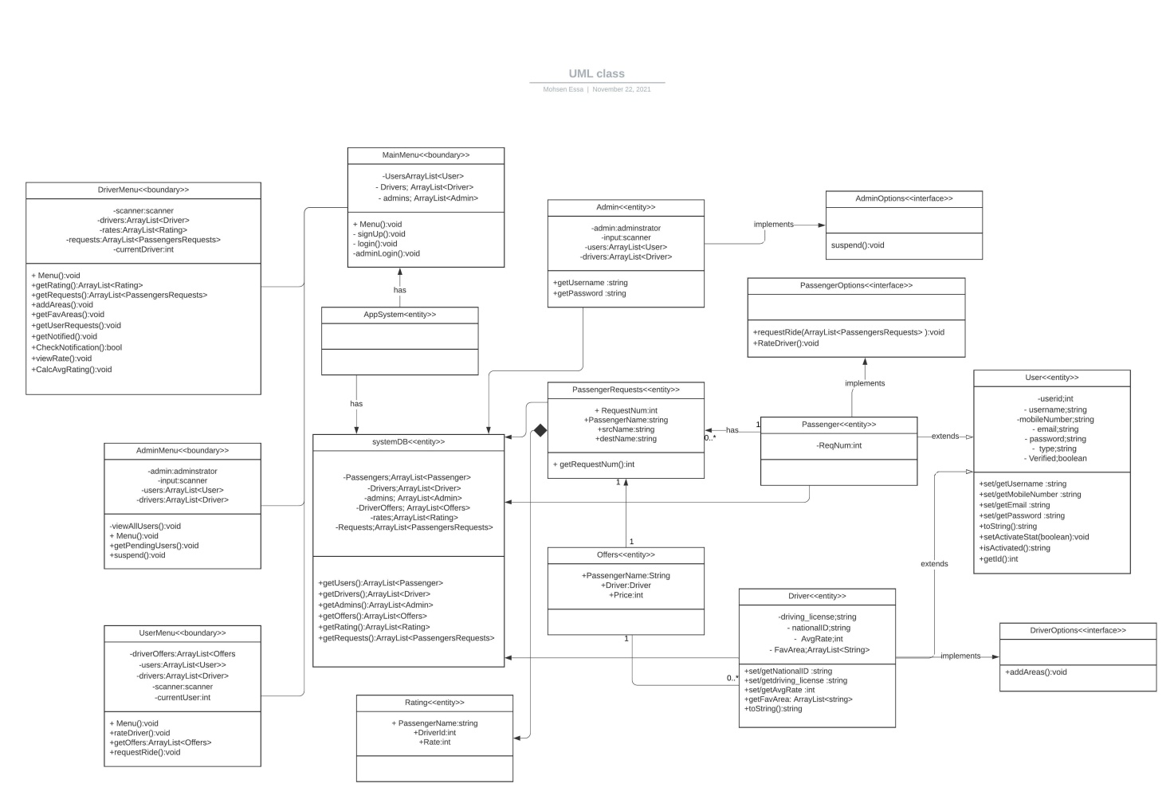

# 

# Sequence diagram design

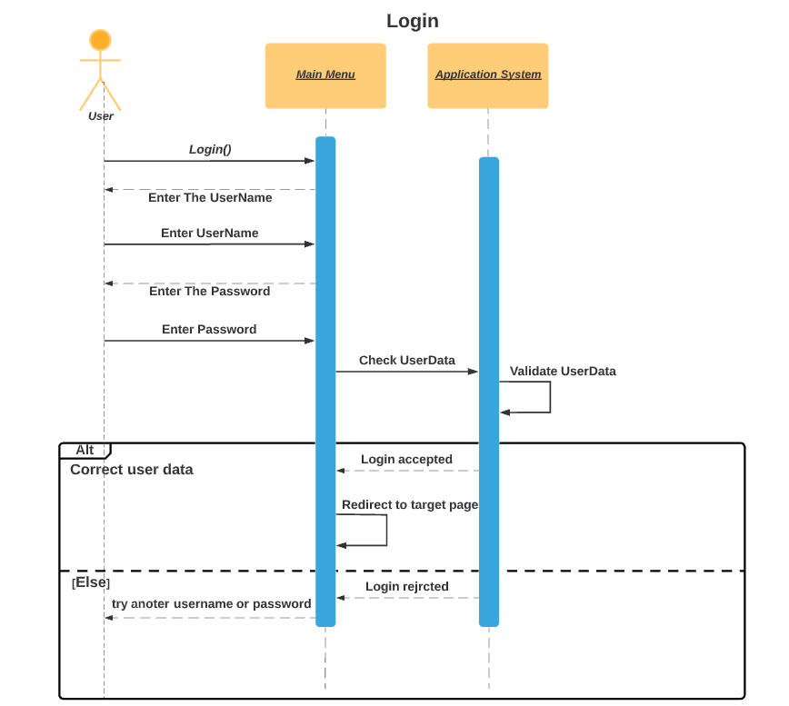

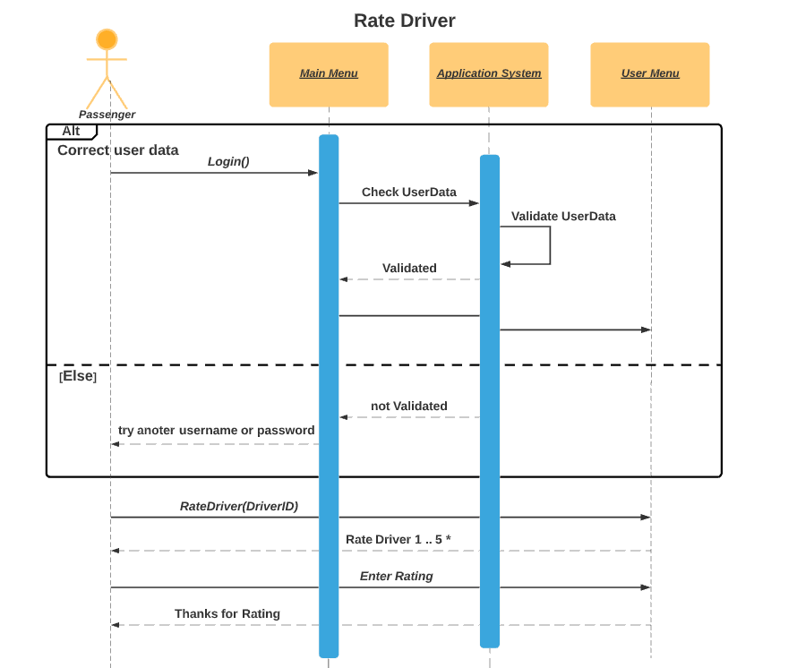

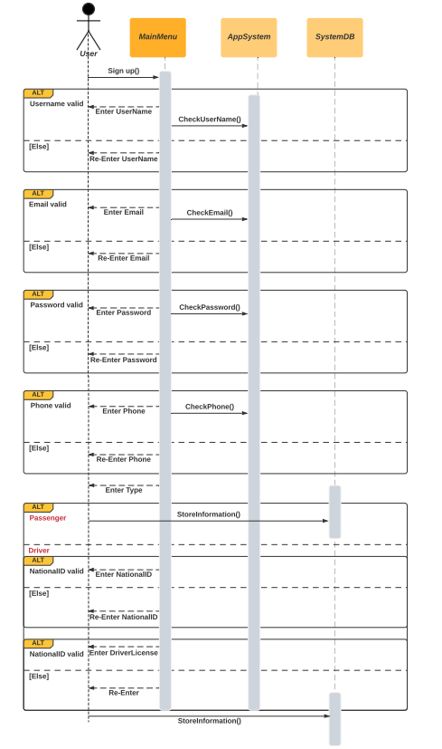

**Sign up**

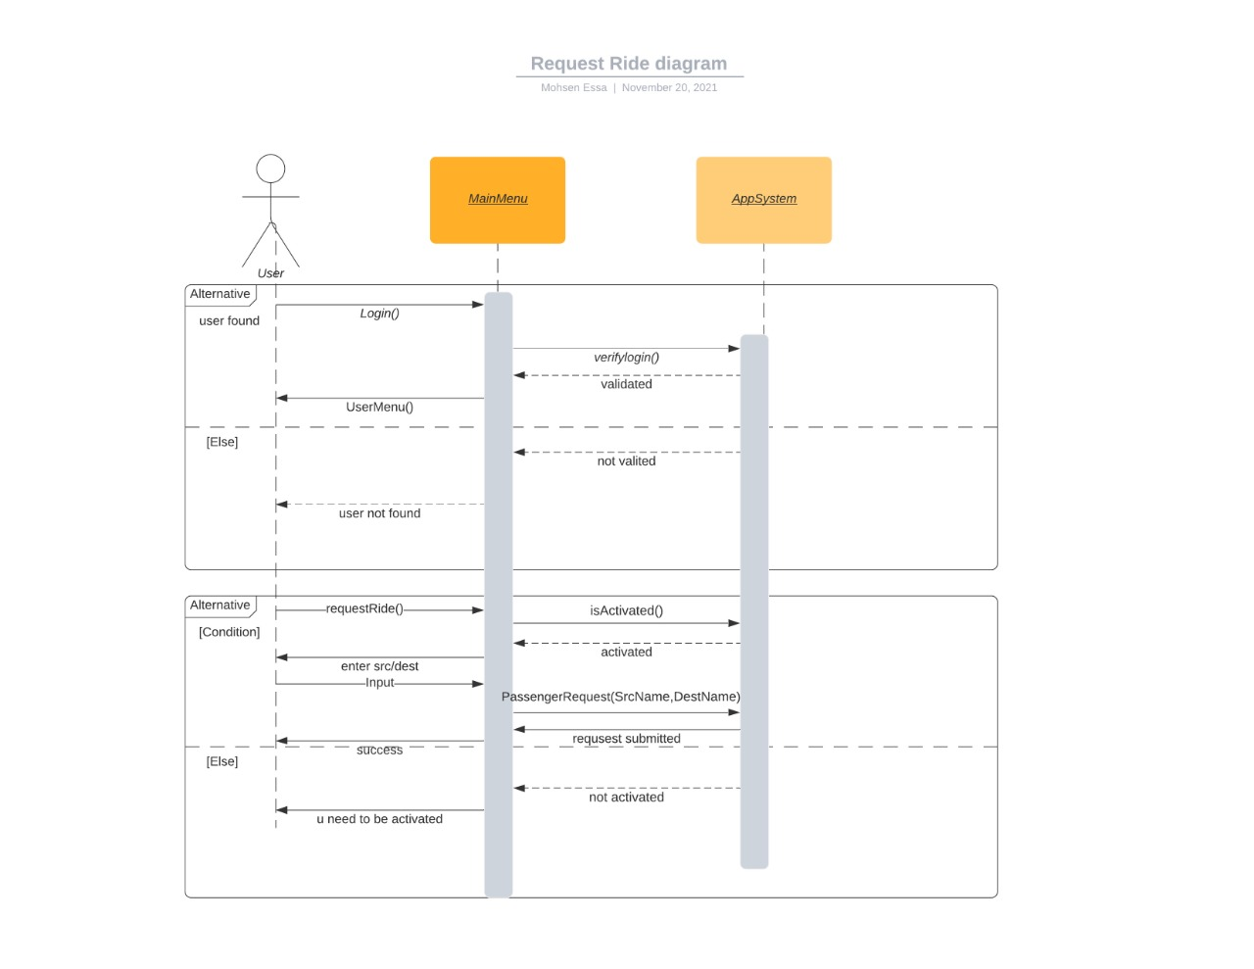

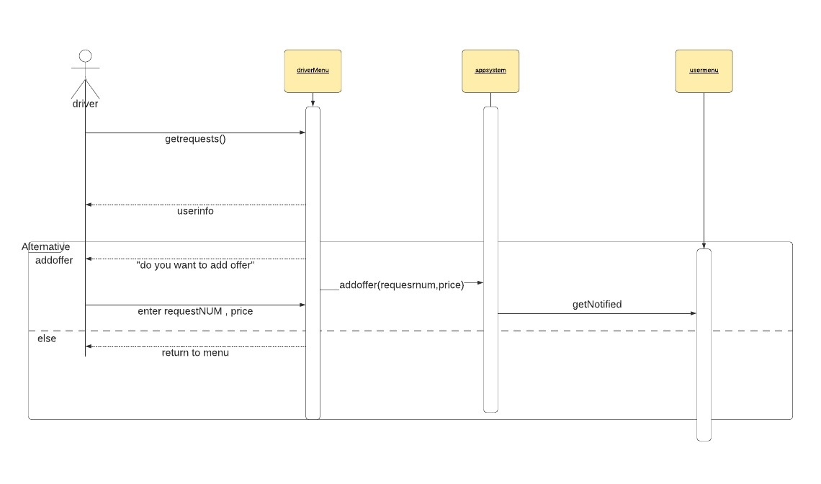

# 

# 

# 

# Github repository link

<https://github.com/EngKarem/ASE-Project>